**Flowering time responses to warming drive reproductive fitness in a changing Arctic**

Courtney G. Collins1, 2, Amy Angert1, 2, Karin Clark3, Sarah Elmendorf4, Cassandra Elphinstone1, 2, 5, and Greg Henry1, 5

1. Biodiversity Research Centre, The University of British Columbia, Vancouver BC, Canada
2. Department of Botany, The University of British Columbia, Vancouver BC, Canada
3. Department of Environment and Natural Resources, Government of the Northwest Territories, Yellowknife, NT, Canada
4. Institute of Arctic and Alpine Research, University of Colorado Boulder, Boulder, CO, USA
5. Department of Geography, The University of British Columbia, Vancouver BC, Canada

**Background and Aims**

The Arctic is warming at an alarming rate, leading to earlier spring conditions and plant phenology. It is often unclear to what degree changes in reproductive fitness (flower, fruit, seed production) are a direct response to warming versus an indirect response through shifting phenology. This study aims to quantify the relative importance of these direct and indirect pathways and project the net effects of warming on plant phenology and reproductive fitness under current and future climate scenarios.

**Methods**

We used two long-term datasets on twelve tundra species in the Canadian Arctic as part of the International Tundra Experiment (ITEX). Phenology and reproductive fitness were recorded annually on tagged individual plants at both Daring Lake, Northwest Territories (64.87, -111.58) and Alexandra Fiord, Nunavut (78.83, -75.80). Observed plant species encompass a wide range of taxonomic diversity and plant functional types with circumpolar or circumboreal distributions. We use Hierarchical Bayesian Structural Equation models to compare the direct and indirect effects of climate warming on phenology and reproductive fitness across species, sites and years.

**Key Results**

We find that warming, both experimental and ambient, drives earlier flowering across species, which leads to higher numbers of flowers and fruits produced, reflecting directional phenotypic selection for earlier flowering phenology. Furthermore, this indirect effect of climate warming mediated through phenology was generally ~2-3x stronger than the direct effect of climate on the number of flowers and fruits. Under future climate predictions, individual plants showed a ~2 to 4.5 fold increase in their reproductive outputs (flower counts).

**Conclusions**

Our results suggest that, on average, the benefits of early flowering, such as increased development time and subsequent enhanced reproductive output, may outweigh its risks. Overall, this work provides important insights into population-level consequences of phenological shifts in a warming Arctic over multi-decadal time scales.

**Keywords**:

Tundra, Arctic, phenology, reproductive fitness, flowering time, climate change

**Introduction**

Shifting plant phenology, i.e., the timing of life cycle events, such as flowering, fruiting, leaf emergence and senescence, among others, is one of the most striking manifestations of climate change in terrestrial ecosystems (Parmesan *et al.* 2003). Such phenological shifts can have profound implications for the growth, survival and reproduction of plant populations, but the consequences of these shifts at the population level are still poorly understood (Mclean *et al.* 2016; Iler *et al.* 2019, 2021; Block *et al.* 2020). While phenological shifts are often assumed beneficial, this is not always the case, as advantageous changes in growth and reproductive timing may incur additional fitness costs. These costs include exposure to extreme weather events (e.g. late season frosts) and altered biotic interactions such as mismatches with pollinators or enhanced herbivory (Inouye 2008; Post *et al.* 2008; Kudo and Ida 2013; Meineke *et al.* 2021; Panchen *et al.* 2021).

Earlier flowering is a commonly observed phenological response to warming temperatures across the globe, particularly in high latitude or high elevation ecosystems (Primack *et al.* 2004; Høye *et al.* 2007; Parmesan 2007; Prevéy *et al.* 2017; Büntgen *et al.* 2022). This trend is robust in both experimentally warmed systems (Arft *et al.* 1999; Collins *et al.* 2021) and with warming patterns in ambient climate (Oberbauer *et al.* 2013; Prevéy *et al.* 2019). Earlier flowering time in response to warming has been associated with increased reproductive fitness including flower, fruit, and seed production (Cleland *et al.* 2012; Iler *et al.* 2021). However, in many cases, it is unclear to what degree this increase in reproductive output is a direct response to climate and/or an indirect effect mediated by shifting phenology. This uncertainty is especially an issue for many temperature-limited species, where both phenology and reproductive fitness may be sensitive to warming (Wookey *et al.* 1993; Henry and Molau 1997; Arft *et al.* 1999; Kudo and Suzuki 2003; Klady *et al.* 2011). Therefore, it is essential to disentangle the direct and indirect effects of climate on plant phenology and reproductive fitness to understand the population-level consequences of phenological shifts under global change.

Advanced flowering phenology over time may reflect a combination of plastic responses to warming temperatures within individuals and differential fitness among individuals if earlier flowering is heritable (Anderson *et al.* 2012; Ehrlén and Valdés 2020). Phenotypic selection analyses (i.e. selection gradients, trait by fitness relationships *sensu* Lande and Arnold 1983) show that directional selection for early flowering is prevalent across systems (Austen *et al.* 2017). However, non-linear relationships between plant phenology and fitness may more accurately reflect how optimal flowering time shifts with growing season length (Weis *et al.* 2014). Life history theory predicts that flowering too early (i.e. before the seasonal optimum), which may lead to reduced resources, has a lower cost than flowering too late, which may result in reproductive failure, thus favoring mid-season flowering phenotypes (Cohen 1971, 1976). However, the extent to which any of these fitness functions occurs in natural populations is difficult to predict for several reasons (Ollerton and Lack 1998; Austen *et al.* 2017), and does not vary consistently across species with climate change (Colautti *et al.* 2017). Thus, we require an improved understanding of how warming temperatures will alter phenology-fitness relationships.

Arctic tundra ecosystems are particularly vulnerable to climate change, with rapid warming leading to significant changes in plant phenology as well as vegetative and reproductive productivity (Klady *et al.* 2011; Post *et al.* 2019; Prevéy *et al.* 2019; Collins *et al.* 2021). However, while advancements in spring phenology are relatively consistent in the tundra, the net demographic (i.e. fitness) impacts of these phenological shifts for tundra plant species are much less predictable (Panchen *et al.* 2021), and as a result, more poorly understood. This is likely for a number of reasons including confounding effects of inter-annual climate on phenology and demographic rates that are often unaccounted for (but see Mortensen *et al.* 2016) or methodological limitations, including the effort involved with recording both individual plant phenology and fitness outcomes over long periods. Studies that have investigated these relationships in the Arctic show contradicting patterns including strong (Mortensen *et al.* 2016) or relatively weak to no effects (Wipf 2010) of changes in phenology on reproductive fitness under climate change. To overcome these limitations, we need additional empirical tests of whether tundra plant species that advance their phenology with warming temperatures have altered (positive or negative) reproductive fitness outcomes over long time scales and across multiple species.

Our study aims to investigate the relationship between plant phenology and reproductive fitness in tundra species under warming conditions. Specifically, we explore the effects of ambient and experimental warming on reproductive fitness both directly and indirectly through shifts in flowering time. We leverage two long-term (30+ site-years total) field monitoring datasets on tagged individual plants from twelve tundra species in the Canadian Arctic as part of the International Tundra Experiment (ITEX) (Henry et al. 2022). Species encompass a wide range of taxonomic diversity and plant functional types with circumpolar or circumboreal distributions (Fig 1).

Our research questions are as follows: 1) How does experimental and ambient warming influence the relationship between plant phenology and reproductive fitness (flower and fruit number) within tundra species? In particular, we are interested to know whether tundra plant species that shift their phenology with warming temperatures have altered (positive or negative) reproductive fitness outcomes. 2) How do the direct effects of warming on reproductive fitness compare to the indirect effects of warming on reproductive fitness mediated by shifting phenology? and 3) How does the relationship between flowering phenology and reproductive fitness shift under future warming scenarios?

**Methods**

**Data collection**

Data were collected from two long-term experimental monitoring sites in the Canadian Arctic as part of the larger International Tundra Experiment (ITEX) network: Alexandra Fiord, NU (78.83°N, -75.80°E), and Daring Lake Tundra Ecosystem Research Station, NT (64.87°N, -111.58°E). Alexandra Fiord is a high Arctic tundra site on the coast of Johan Peninsula of east-central Ellesmere Island in subzone C of the Circum-Arctic Vegetation Map (CAVM). Daring Lake is located about 70 km north of the present-day treeline in the Southern Arctic Ecozone within the Tundra Shield Low Arctic Ecoregion (Ecosystem Classification Group 2012), which is subzone E of the CAVM (Walker et al. 2005). From 2001- current, average spring (April, May), summer (June-Aug) and fall (September, October) air temperatures at Daring Lake were -8.6, 10.9 and -0.46°C respectively and at Alexandra Fiord were -16.2, 3.7, and -9.6°C respectively.

Phenology and reproductive fitness data were generated from long-term monitoring programs at both sites over the last 3 decades. At Daring Lake, repeat measurements were made from 2001-2022 on tagged individual plants within designated areas defined by the dominant plant species for seven common tundra species (n~20 individuals per species). At Alexandra Fiord, repeat measurements were made from 1992-2003 on tagged individuals for five common tundra species inside and out of experimental warming open top chambers (OTCs). Individual plants were re-visited within the same growing season but not across all years at Alexandra Fiord, as new individuals were chosen after plant death or lost tags. Species at both sites incorporate a wide range of taxonomic diversity and plant functional types (woody, herbaceous, deciduous, evergreen, shrub, graminoid, forb, cushion) and reflect circumpolar/circumboreal distributions (Fig 1, Table S1). We define flowering date as the date (i.e. day of year) of the first mature (i.e. open) flower and the reproductive fitness as the total number of reproductive structures (flowers, fruits) in a given individual in a given year.

Climate data were collected from automatic weather stations (1.5 - 2m height) at both sites and snow free dates were recorded from visual observations for each plot/species. Average growing season temperatures at Daring Lake have warmed substantially over the 21-year study period (Fig 3a) but show no consistent temporal trend at Alexandra Fiord over the 10-year study period (Fig S1b). However, during peak flowering OTCs warm tundra plant communities between 1-2 °C at Alexandra Fiord depending on location and time of day (Fig 3b, data from Hollister *et al.* 2023). Thus, we focused on the effects of ambient climate warming at Daring Lake and the effects of experimental warming at Alexandra Fiord.

**Statistical modeling**

*Daring Lake: Ambient climate warming as driver*

For the Daring Lake dataset, to determine which climate parameters best predicted annual phenology and reproductive fitness individually, we used a model selection approach with linear mixed effects models in the R packages lme4 (v1.1-31) (Bates *et al.* 2014) and AICcmodavg (v2.3-1) (Mazerolle 2023). We included the following climate parameters in these models: Site-level average daily growing season (June-August) temperature (°C) of the (1) current year (2) the previous year and (3) snowmelt timing (day of year-DOY) in the current year. All models had all possible combinations of either one, two or three of the above climate parameters and random intercepts of species, individual plant id nested within species and calendar year. We then used AIC model comparison to determine the most parsimonious model for both phenology (date of flowering), and reproductive fitness (flower number, fruit number) respectively and used the climate predictors from the best models in downstream analyses (Table 1).

Next, we used a piecewise structural equation modeling approach in a Bayesian framework by fitting multivariate hierarchical models with default (non-informative) priors in the R package brms (v 2.18.0) (Bürkner 2018). Broadly, we used the best climate predictors from model selection (above) to predict individual plant flowering phenology (Table 1). Then, in an SEM framework, we predicted reproductive fitness of the same individual plant in the same year with flowering time from the previous model and the best respective climate predictor (Fig 2). For flower number this was the average growing season (June-Aug) temperature of the current year (Tempt -Table 1) and for fruit number, this was the average growing season temperature (June- Aug) of the previous year (Tempt-1-Table 1). In the fruit number SEM; we also included prior average growing season temperature as a predictor of flowering phenology for consistency between phenology and reproductive fitness models (Eq 1b). Our modeling approach is similar to those used by Mclean *et al.* (2016) and Mortensen *et al.* (2016).

All models included random intercept terms for species, plant individual nested within species and calendar year. All data were mean centered with a mean=0, sd=1 for comparison of parameter estimates across models (Eq 1a, b). We used Gaussian (or skew normal) distributions for all phenology and fitness response variables and we logged count variables (number of flowers, fruits) for normality prior to modeling. Flower counts by definition were non-zero as the same individual plant flowering phenology (DOY) was included as a model covariate. Fruit counts could be zero when an individual flowered but did not fruit. We included linear terms for all relationships in the model and an additional quadratic term to the phenology-fitness relationship to allow for stabilizing or disruptive selection gradients (Eq 1a, b, Fig 2). While we do not have fruit count data for all species, for the species where both fruit and flower counts were recorded, these metrics were (moderately to strongly) positively correlated within individuals over time (Fig S2). Thus, we feel that flower counts may serve as a reasonable proxy for reproductive fitness in this system in the absence of fruit count data.

Eq. 1a Number of flowers

DOYflower ~ Tempt + (1|species:individual) + (1|year) + (1|species)

Fitness ~ Tempt  + DOYflower + DOYflower2+ (1|species:individual) + (1|year) + (1|species)

Eq. 1b Number of fruit

DOYflower ~ Temp + Tempt-1 + (1|species:individual) + (1|year) + (1|species)

Fitness ~ Tempt-1 + DOYflower + DOYflower2 + (1|species:individual) + (1|year) + (1|species)

*Alexandra Fiord: Climate warming experiment*

For the Alexandra Fiord dataset, we used a very similar modeling approach, however for climate we included a categorical predictor of treatment (OTC warming or control) (Eq 2, Fig 2). Thus, we first estimated the experimental warming effect (OTC vs. control) on flowering phenology and then, in an SEM framework, we predicted reproductive fitness of the same individual plant in the same plot-year with its flowering time from the previous model and the direct effect of the warming treatment.

All Alexandra Fiord models included random intercept terms for species, experimental plot nested within experimental location (i.e. subsite), and calendar year (Eq. 2). Because we are interested in broad patterns of phenology-fitness relationships across tundra species, we include group level intercepts by species rather than group level slopes. Model parameter estimates with group level intercepts and slopes by species are very similar, but larger error estimates limited our ability to detect general patterns using group level slopes. All (non-count) data were mean centered with a mu=0, sd=1 for comparison of parameter estimates across models. We used Gaussian distributions for phenology responses and lognormal distributions (link= “identity”) for all fitness (number of flowers, fruits) response variables. Flower counts by definition were non-zero as the same individual plant flowering phenology (DOY) was included as a model covariate. Fruit counts could be zero when an individual flowered but did not fruit. We included linear terms for all relationships in the model and an additional quadratic term to the phenology-fitness relationship to allow for stabilizing or disruptive selection gradients (Eq 2, Fig 2). While we do not have fruit count data for all species, for the species where both fruit and flower counts were recorded, these metrics were positively correlated within individuals over time (Fig S2). Thus, we feel that flower counts may serve as a reasonable proxy for reproductive fitness in this system in the absence of fruit count data.

Eq. 2

DOYflower~ Treatment + (1|subsite:plot) + (1|year) + (1|species)

Fitness ~ Treatment + DOYflower + DOYflower2 + (1|subsite:plot) + (1|year) + (1|species)

All models were run with 3 chains of 10000 iterations each (warm-up 5000 iterations, no thinning) Markov Chain Monte Carlo (MCMC) sampling. We checked for convergence of chains for all parameters both visually with trace plots and with the R-hat convergence diagnostic. Trace plots showed that chains mixed well and converged to stationary distributions for all parameter estimates. R-hat values for parameter estimates of all models were less than 1.1. We calculated Bayesian credible intervals for all fixed model parameters in the R package BayestestR (v 0.90) (Makowski *et al.* 2019) using the equal tailed interval (eti) method and consider modeled parameter estimates to demonstrate an effect on the response variable when 95% Bayesian CIs did not contain zero.

We performed posterior predictive checks of model performance using the ‘pp_check’ function of brms and leave-one-out (LOO) cross-validation in the R package loo (v 2.5.1) (Vehtari *et al.* 2017) ensuring all pareto k values reflecting good data-model fit (k <0.7). For one model that had observations with pareto k values > 0.7, we re-fit the model leaving out the problematic observations (n=10, 2%) with the function ‘reloo’ and report both cross validation results (See Appendix 1). Finally, we calculated LOO-adjusted bayesian R2 values for each model with the ‘loo_R2’ function in brms.

*Future climate projections*

To illustrate the consequences of direct vs. indirect effects (mediated through phenology) of anticipated climate warming, we generated model projections over novel climate space for Daring Lake only, as Alexandra fiord models used categorical predictor of warming. To do this, we created 3 climate scenarios: +1, +3, and +5 degrees C warming over average growing season temperatures from 2001-2022. We then used existing models to project future changes in phenology and its corresponding effect on reproductive fitness (flower number, fruit number) over the novel climate data with the ‘predictions’ and ‘posterior_draws’ functions in the R package marginaleffects (v 0.11.0) (Arel-Bundock 2023). Our goal was to quantify potential changes in reproductive output under climate change with and without accompanying phenological shifts as estimated by our models. We acknowledge that these projections include extrapolating outside the climate space experienced by our plants thus far, so interpretation of these results depends on the capacity of the species studied to keep pace with continued climate warming, for which the evidence is mixed (Fu *et al.* 2015).

**Results**

*Climate and experimental warming*

Average growing season air temperatures at Daring Lake, NWT increased approximately 2.4 degrees C over the 21-year study period at this site (2001-2022) (Fig 3a). This exceeds timeline projections for reaching 2 degrees of Arctic warming as a whole over 1980-2005 levels (Post *et al.* 2019) and highlights the enhanced rate of warming in continental Arctic Zones like the Northwest Territories (Haynes *et al.* 2018). Snowmelt timing showed a slight, but not statistically significant, pattern of advancement over this period (Fig S1a). However, AIC model selection indicated that growing season temperature was a better predictor of flowering phenology and reproductive fitness than snow-free DOY (Table 1).

At Alexandra Fiord, NU, experimental warming increased the average temperature across the growing season by 1.13 degrees C as compared to control plots (Fig 3b- dotted red line), particularly during July (DOYs 190-210) when most plants are flowering (Fig 3b- solid blue line). In contrast to Daring Lake, average growing season temperatures showed a weakly positive but not statistically significant temporal trend over the 10-year study period under ambient conditions (Fig S1b).

*Warming and flowering phenology*

Warming (both warmer growing season temperatures and experimental warming) had a negative statistical relationship with flowering phenology (i.e. warmer temperatures led to earlier flowering) (Table 2, Fig 4). Structural equation modeling showed that flowering time advanced between 0.35-0.75 days per degree C of warming overall (Table 2, Fig 4).

*Direct and indirect effects on reproductive fitness*

Warming (both warmer growing season temperatures and experimental warming) had weak to no direct relationship with reproductive fitness. Structural equation modeling showed that flower number increased 0.12 flowers per degree C of warming at Daring Lake (Fig 4b) and decreased 0.11 flowers per degree C of warming (i.e. approximate effect of OTC) at Alexandra Fiord (Fig 4c), while the remaining two models (Fig 4a, d) showed no direct effect of warming on reproductive fitness.

In contrast, the downstream effects of phenology (DOY flowering) had consistently negative relationships with reproductive fitness (i.e. earlier phenology led to a *higher* number of flowers, fruits) across all species, sites and years (Table 2, Fig 4). Structural equation modeling showed that reproductive fitness increased by 0.13-0.26 flowers, fruits per day advance of flowering phenology and the average magnitude of this effect was comparable across sites (Alexandra Fiord and Daring Lake) (Fig 4). Overall, the indirect effects of warming mediated through phenology were ~1.8 to 3x stronger than the direct effects of warming on reproductive fitness based on mean parameter estimates within a given model (Table 2, Fig 4).

*Sources of variation*

Model R2 values indicate much higher predictive power for plant phenology than reproductive fitness across sites (Fig 4). Some models of reproductive fitness show poor predictive power despite evidence of phenology shifts, particularly with categorical rather than continuous temperature.

Group level parameters (i.e. random intercepts) showed different sources of variation in phenology and reproductive fitness between the two sites. At Daring Lake, species, followed by calendar year accounted for the largest amount of the variation in flowering phenology, while species and individual plant ID accounted for the largest amount of the variation in reproductive fitness. Thus, intraspecific variation among individuals was much higher for reproductive output than for flowering phenology. Rather, flowering phenology varied mostly between species within a given year and across years (i.e. intra/inter-annually). Interestingly, at Alexandra Fiord, we found a different pattern whereby calendar year, followed by species, accounted for the largest amount of the variation in both flowering phenology and reproductive fitness. Thus inter-annual variation in reproductive timing and fitness outweighed species level variation at this site. Plot (i.e. location) also accounted for significant variation in flowering phenology, but to a lesser extent in reproductive fitness, suggesting a potential role of microhabitat on flowering phenology (Table 3).

*Phenotypic selection analysis*

We find consistent evidence of directional phenotypic selection for earlier flowering phenology under warming in that all warming-to-phenology relationships are negative and all phenology-to-fitness relationships are also negative (i.e. warming leads to earlier flowering leads to higher fitness) (Table 2, Figure 4, 5). We find weak to no evidence for stabilizing or disruptive phenotypic selection. The two quadratic terms whose parameter estimates do not include zero (Table 2, Fig 4 b,c) are 2-4x smaller than the linear terms of the same relationship and are very weakly concave (Fig 5 b,d).

*Future projections*

Model projections of reproductive fitness under novel climate space illustrate how phenological shifts are key to increased reproductive output under warming conditions. For Daring Lake, under the historic (2001-2022) average growing season temperatures +1 C and + 3C scenarios, which both encompass historically observed temperatures at this site, models predict an advance in the median spring flowering phenology by ~6 to 20 days for 1 C and 3C respectively. This translates to a 129-238% increase in reproductive output for an individual that flowers at the projected median day of year (DOY 167 (+1C), DOY 155 (3C). However, if plants were not able to respond phenologically (e.g. if daylength or some other factor constrained flowering timing and thus the flowering period remained the same), we would only project a 114-145% increase in reproductive output due to the direct positive effects of warming. (Fig 6, Table 4). Under the historic average +5 C scenario, which extrapolates outside of historically observed temperatures at this site, flowering times are projected to shift ~30 days earlier corresponding to 457% increase in reproductive output if flowering phenology keeps pace with the rate of warming, compared with a 231% increase in reproductive output from warming alone (Fig 6, Table 4).

**Discussion**

Documenting shifts in plant phenology under climate change has been an important scientific achievement of the past few decades, yet determining the potential demographic and population level consequences of these shifts remains a challenge (Iler *et al.* 2021). This is likely due not only to methodological constraints, (e.g. phenology and demographic studies require different monitoring capabilities, time-frames), but also the need for improved discussion across sub-disciplines, as research questions framed for phenology often assume implicit links to fitness that may or may not exist (Kharouba and Wolkovich 2022). Proposed approaches to make these mechanistic links include statistically relating demographic vital rates to phenology rather than analyzing them separately and the use of Structural Equation Models to separate direct and indirect effects of climate on these processes (Iler *et al.* 2021). Here we utilize both of these approaches and a unique 30+ year dataset of Arctic plant phenology to show that the effects of plant phenology on plant reproductive fitness (i.e. fecundity) may be larger than previously thought, and between 2-3 x the magnitude of the direct effects of warming. Given the broad coverage of circumpolar species and functional groups in our study and the length of the observations of responses, we can expect that shifting phenology will have similar effects on reproductive fitness across the tundra biome.

A substantial body of work in tundra ecosystems has documented earlier flowering timing, increased reproduction, or both responses to warming (Wookey *et al.* 1993; Henry and Molau 1997; Arft *et al.* 1999; Totland and Alatalo 2002; Klady *et al.* 2011; Frei and Henry 2022; Becker-Scarpitta *et al.* 2023). To date, none have leveraged concurrent measurements on phenology and reproduction to ask whether warming temperatures directly stimulate plant reproduction regardless of flowering time, or whether this climatic effect is driven by plant phenological responses. Here we find that it is primarily the latter, and find very little evidence of warming effects on reproductive fitness independent of flowering phenology. This suggests that the increased development time associated with advanced flowering in response to warming is the dominant pathway leading to enhanced reproductive performance.

We find evidence of strong directional phenotypic selection for earlier flowering across tundra plant species over multi-decadal time scales. Interestingly, we find little evidence of non-linear selection gradients reflecting stabilizing or disruptive selection, however we cannot rule out the potential for higher order polynomial or non-parametric relationships (Weis *et al.* 2014). Reproductive fitness is only one component of the plant's life cycle and does not always correlate with changes in population growth or species relative abundances (Iler *et al.* 2019). Furthermore, phenotypic selection may be dependent on the environmental context of flowering individuals (microhabitat quality etc.) (Austen *et al.* 2017). While we do not have information on individual level microenvironment, model hyperparameters showed that intraspecific variation among individuals was much higher for reproductive output than for flowering phenology, suggesting that environmental or other contexts of individuals (age, size, pollinator availability etc.) may play an important role in their reproductive fitness. This also corresponds with much lower explanatory power for reproductive fitness than phenology models. Rather, flowering phenology varied mostly between species over time (i.e. inter-annually), reflecting a high level of macroclimatic control, which is consistent with modeled parameter estimates. Despite these caveats, positive fitness outcomes for earlier flowering individuals under warming highlights the capacity of these temperature-sensitive tundra species to acclimate to warmer temperatures and may reduce the need for alternate intervention strategies such as assisted migration of southern populations. These results are in line with a growing understanding of how intraspecific trait variation in tundra plant communities may slow species turnover and promote ecosystem resistance to climate warming in the Arctic (Jónsdóttir *et al.* 2023).

While we find strong evidence that warming temperatures are shifting phenology, and as a result, reproductive fitness, there are still many other ecological drivers at play in our system. Previous work at the Alexandra Fiord site found has found both positive (Klady *et al.* 2011) and inconsistent (positive, negative, and no effect) (Frei and Henry 2022) direct effects of experimental warming on the reproductive output of dominant tundra species different species. However, these studies highlight that the effects of experimental warming on reproductive output can be modulated by other environmental factors such as snowpack. Our work adds to this understanding by showing how the indirect effects of warming via shifting phenology is what primarily drives changes in reproductive fitness within an individual plant. Similarly, Wipf (2010) finds that both phenology and fecundity of subarctic species were influenced by snowmelt date, particularly early in the growing season, whereas later season phenophases were more driven by temperature (i.e. GDDs). While we did not find strong effects of snowmelt date on fruit and flower production in our study, snowmelt date does influence flowering phenology, but only when combined with air temperature (Table 1). Other factors including changes in snowpack depth, and sea ice thaw and extent, require further consideration (Assmann *et al.* 2019).

Under future climate predictions, individual plants showed a ~2 to 4.5 fold increase in their reproductive output (flower counts) under the most extreme model projections (+3, +5C above historic growing season temperatures). However, if individual plants are unable to shift their flowering times concurrent with this rapid warming, approximately 20-30 day advances in the median flowering time, these projections are much more moderate (1.5 – 2.3 fold increase). There are several reasons why plants may become limited in their ability to shift flowering times by this magnitude, including photoperiod limitation, reduced chilling, and/or stronger winter warming (Fu *et al.* 2015). In addition, temperature stress on tundra plants may even reduce flower or fruit production under extremely warm temperatures (Notarnicola *et al.* 2022). A warmer Arctic will also be much cloudier with potential for greater changes in precipitation from snow to rain (McIlhattan *et al.* 2020), which could affect advances in spring phenology and the lack of direct sun may also affect flower production in some species. While 5C warming is currently well within model projections for winter temperatures in the Arctic (Post *et al.* 2019), summer warming is less extreme (Bintanja and van der Linden 2013), and thus we do not know with certainty whether these most extreme growing season temperatures will be observed in this century. Nonetheless, the Arctic is warming at 4x the rate of the global average (Rantanen *et al.* 2022), with particularly alarming heat and wildfires in recent years in the Northwest Territories (NT, Canada) (Porter *et al.* 2019; Gaboriau *et al.* 2023) thus justifying the need for extreme projections outside of historically observed temperatures.

In conclusion**,** this work provides important insights into both estimated and predicted fitness consequences of phenological shifts in a warming Arctic over multi-decadal time scales. In both current (1990s-2020s) and future climate scenarios, we can expect earlier flowering to benefit plant reproduction, given that phenological shifts can keep pace with warmer temperatures. Thus, flowering phenology may act as an important mechanism by which tundra plant populations acclimate or adapt to changing environmental conditions. These findings have important implications for predicting the impacts of climate change on Arctic ecosystems. Further research is needed to determine how these changes in fitness as a result of advancing phenology will or will not scale up to changes in the abundance of tundra species.

**References**

**Anderson JT, Inouye DW, McKinney AM, Colautti RI, Mitchell-Olds T**. **2012**. Phenotypic plasticity and adaptive evolution contribute to advancing flowering phenology in response to climate change. *Proceedings of the Royal Society B: Biological Sciences* **279**: 3843–3852.

**Arel-Bundock V**. **2023**. *marginaleffects: Predictions, Comparisons, Slopes, Marginal Means, and Hypothesis Tests*.

**Arft AM, Walker MD, Gurevitch J, *et al.*** **1999**. Responses of Tundra plants to experimental warming: Meta-analysis of the International Tundra Experiment. *Ecological Monographs* **69**: 491–511.

**Assmann JJ, Myers-Smith IH, Phillimore AB, *et al.*** **2019**. Local snow melt and temperature—but not regional sea ice—explain variation in spring phenology in coastal Arctic tundra. *Global Change Biology* **25**: 2258–2274.

**Austen EJ, Rowe L, Stinchcombe JR, Forrest JRK**. **2017**. Explaining the apparent paradox of persistent selection for early flowering. *New Phytologist* **215**: 929–934.

**Bates D, Mächler M, Bolker B, Walker S**. **2014**. Fitting linear mixed-effects models using lme4. *Journal of Statistical Software* **67**.

**Becker-Scarpitta A, Antão LH, Schmidt NM, *et al.*** **2023**. Diverging trends and drivers of Arctic flower production in Greenland over space and time. *Polar Biology*.

**Bintanja R, van der Linden EC**. **2013**. The changing seasonal climate in the Arctic. *Scientific Reports* **3**: 1556.

**Block S, Alexander JM, Levine JM**. **2020**. Phenological plasticity is a poor predictor of subalpine plant population performance following experimental climate change. *Oikos* **129**: 184–193.

**Büntgen U, Piermattei A, Krusic PJ, Esper J, Sparks T, Crivellaro A**. **2022**. Plants in the UK flower a month earlier under recent warming. *Proceedings of the Royal Society B: Biological Sciences* **289**: 20212456.

**Bürkner P-C**. **2018**. Advanced Bayesian Multilevel Modeling with the R Package brms. *The R Journal* **10**: 395.

**Cleland EE, Allen JM, Crimmins TM, *et al.*** **2012**. Phenological tracking enables positive species responses to climate change. *Ecology* **93**: 1765–1771.

**Cohen D**. **1971**. Maximizing final yield when growth is limited by time or by limiting resources. *Journal of Theoretical Biology* **33**: 299–307.

**Cohen D**. **1976**. The Optimal Timing of Reproduction. *The American Naturalist* **110**: 801–807.

**Colautti RI, Ågren J, Anderson JT**. **2017**. Phenological shifts of native and invasive species under climate change: insights from the Boechera–Lythrum model. *Philosophical Transactions of the Royal Society B: Biological Sciences* **372**: 20160032.

**Collins CG, Elmendorf SC, Hollister RD, *et al.*** **2021**. Experimental warming differentially affects vegetative and reproductive phenology of tundra plants. *Nature Communications* **12**.

**Ehrlén J, Valdés A**. **2020**. Climate drives among-year variation in natural selection on flowering time. *Ecology Letters* **23**: 653–662.

**Frei ER, Henry GHR**. **2022**. Long-term effects of snowmelt timing and climate warming on phenology, growth, and reproductive effort of Arctic tundra plant species. *Arctic Science* **8**: 700–721.

**Fu YH, Zhao H, Piao S, *et al.*** **2015**. Declining global warming effects on the phenology of spring leaf unfolding. *Nature* **526**: 104–107.

**Gaboriau DM, Chaste É, Girardin MP, *et al.*** **2023**. Interactions within the climate-vegetation-fire nexus may transform 21st century boreal forests in northwestern Canada. *iScience* **26**: 106807.

**Henry GHR, Molau U**. **1997**. Tundra plants and climate change: The international tundra experiment (ITEX). *Global Change Biology* **3**: 1–9.

**Hollister RD, Elphinstone C, Henry GHR, *et al.*** **2023**. A review of open top chamber (OTC) performance across the ITEX Network. *Arctic Science* **9**: 331–344.

**Høye TT, Post E, Meltofte H, Schmidt NM, Forchhammer MC**. **2007**. Rapid advancement of spring in the High Arctic. *Current Biology* **17**: 449–451.

**Iler AM, CaraDonna PJ, Forrest JRK, Post E**. **2021**. Demographic Consequences of Phenological Shifts in Response to Climate Change. *Annual Review of Ecology, Evolution, and Systematics* **52**.

**Iler AM, Compagnoni A, Inouye DW, *et al.*** **2019**. Reproductive losses due to climate change-induced earlier flowering are not the primary threat to plant population viability in a perennial herb. *Journal of Ecology* **107**: 1931–1943.

**Inouye DW**. **2008**. Effects of Climate Change on Phenology, Frost Damage, and Floral Abundance of Montane Wildflowers. *Ecology* **89**: 353–362.

**Jónsdóttir IS, Halbritter AH, Christiansen CT, *et al.*** **2023**. Intraspecific trait variability is a key feature underlying high Arctic plant community resistance to climate warming. *Ecological Monographs* **93**.

**Kharouba HM, Wolkovich EM**. Lack of evidence for the match-mismatch hypothesis across terrestrial trophic interactions. *Ecology Letters* **n/a**.

**Klady RA, Henry GHR, Lemay V**. **2011**. Changes in high arctic tundra plant reproduction in response to long-term experimental warming. *Global Change Biology* **17**: 1611–1624.

**Kudo G, Ida TY**. **2013**. Early onset of spring increases the phenological mismatch between plants and pollinators. *Ecology* **94**: 2311–2320.

**Kudo G, Suzuki S**. **2003**. Warming effects on growth, production, and vegetation structure of alpine shrubs: a five-year experiment in northern Japan. *Oecologia* **135**: 280–287.

**Lande R, Arnold SJ**. **1983**. The Measurement of Selection on Correlated Characters. *Evolution* **37**: 1210–1226.

**Makowski D, Ben-Shachar M, Lüdecke D**. **2019**. bayestestR: Describing Effects and their Uncertainty, Existence and Significance within the Bayesian Framework. *Journal of Open Source Software* **4**: 1541.

**Mazerolle MJ**. **2023**. AICcmodavg: Model selection and multimodel inference based on (Q)AIC(c).

**McIlhattan EA, Kay JE, L’Ecuyer TS**. **2020**. Arctic Clouds and Precipitation in the Community Earth System Model Version 2. *Journal of Geophysical Research: Atmospheres* **125**: e2020JD032521.

**Mclean N, Lawson CR, Leech DI, van de Pol M**. **2016**. Predicting when climate-driven phenotypic change affects population dynamics. *Ecology Letters* **19**: 595–608.

**Meineke EK, Davis CC, Davies TJ**. **2021**. Phenological sensitivity to temperature mediates herbivory. *Global Change Biology* **27**: 2315–2327.

**Mortensen LO, Schmidt NM, Høye TT, Damgaard C, Forchhammer MC**. **2016**. Analysis of trophic interactions reveals highly plastic response to climate change in a tri-trophic High-Arctic ecosystem. *Polar Biology* **39**: 1467–1478.

**Notarnicola RF, Nicotra AB, Kruuk LEB, Arnold PA**. **2022**. Effects of warming temperatures on germination responses offs between seed traits in an alpine plant. : 1–15.

**Oberbauer SF, Elmendorf SC, Troxler TG, *et al.*** **2013**. Phenological response of tundra plants to background climate variation tested using the International Tundra Experiment. *Philosophical Transactions of the Royal Society B: Biological Sciences* **368**.

**Ollerton J, Lack A**. **1998**. Relationships between flowering phenology, plant size and reproductive success in Lotus corniculatus (Fabaceae). *Plant Ecology* **139**: 35–47.

**Panchen ZA, Frei ER, Henry GHR**. **2021**. Increased Arctic climate extremes constrain expected higher plant reproductive success in a warmer climate. *Arctic Science*: 1–38.

**Parmesan C**. **2007**. Influences of species, latitudes and methodologies on estimates of phenological response to global warming. *Global Change Biology* **13**: 1860–1872.

**Parmesan C, Parmesan C, Yohe G, Yohe G**. **2003**. A globally coherent fingerprint of climate change impacts across natural systems. *Nature* **421**: 37–42.

**Porter TJ, Schoenemann SW, Davies LJ, Steig EJ, Bandara S, Froese DG**. **2019**. Recent summer warming in northwestern Canada exceeds the Holocene thermal maximum. *Nature Communications* **10**: 1631.

**Post E, Alley RB, Christensen TR, *et al.*** **2019**. The polar regions in a 2°C warmer world. *Science Advances* **5**.

**Post E, Pedersen C, Wilmers CC, Forchhammer MC**. **2008**. Warming, plant phenology and the spatial dimension of trophic mismatch for large herbivores. *Proceedings of the Royal Society B: Biological Sciences* **275**: 2005–2013.

**Prevéy JS, Rixen C, Rüger N, *et al.*** **2019**. Warming shortens flowering seasons of tundra plant communities. *Nature Ecology and Evolution* **3**: 45–52.

**Prevéy J, Vellend M, Rüger N, *et al.*** **2017**. Greater temperature sensitivity of plant phenology at colder sites: implications for convergence across northern latitudes. *Global Change Biology* **23**: 2660–2671.

**Primack D, Imbres C, Primack RB, Miller-Rushing AJ, Del Tredici P**. **2004**. Herbarium specimens demonstrate earlier flowering times in response to warming in Boston. *American Journal of Botany* **91**: 1260–1264.

**Rantanen M, Karpechko AY, Lipponen A, *et al.*** **2022**. The Arctic has warmed nearly four times faster than the globe since 1979. *Communications Earth & Environment* **3**: 1–10.

**Totland Ø, Alatalo JM**. **2002**. Effects of temperature and date of snowmelt on growth, reproduction, and flowering phenology in the arctic/alpine herb, Ranunculus glacialis. *Oecologia* **133**: 168–175.

**Vehtari A, Gelman A, Gabry J**. **2017**. Practical Bayesian model evaluation using leave-one-out cross-validation and WAIC. *Statistics and Computing* **27**: 1413–1432.

**Weis AE, Wadgymar SM, Sekor M, Franks SJ**. **2014**. The shape of selection: using alternative fitness functions to test predictions for selection on flowering time. *Evolutionary Ecology* **28**: 885–904.

**Wipf S**. **2010**. Phenology, growth, and fecundity of eight subarctic tundra species in response to snowmelt manipulations. *Plant Ecology* **207**: 53–66.

**Wookey PA, Parsons AN, Welker JM, *et al.*** **1993**. Comparative Responses of Phenology and Reproductive Development to Simulated Environmental Change in Sub-Arctic and High Arctic Plants. *Oikos* **67**: 490–502.

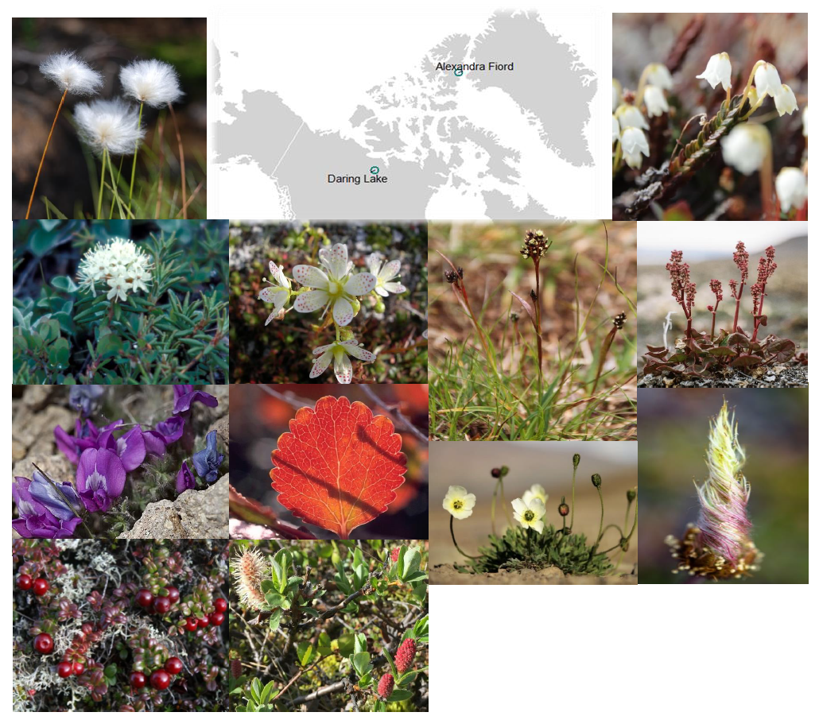

**Fig 1.** Circumpolar/boreal tundra species included in this study (also see Table S1). Species from Daring Lake in left two columns and from Alexandra Fiord in right two columns. From top left counter-clockwise: *Eriophorum vaginatum, Rhododendron tomentosum, Oxytropis nigrescens, Vaccinium vitis-idaea, Salix pulchra/planifolia, Betula glandulosa, Saxifraga tricuspidata.* Photo credits: Karin Clark and Jacob W. Frank (Creative commons Attribution Generic 2.0 (Oxytropis)). From top right clockwise: *Cassiope tetragona, Oxyria dignya, Dryas integrifolia, Papaver radicatum, Luzula arctica/confusa.* Photo credits Nicola Rammell, Katriina O’Kane, Anne Bjorkman, and Erlend Bjoertvedt (Creative commons Attribution Share Alike 3.0 (Luzula)). Please note species with dual names (/) had two indistinguishable (and sometimes hybrid) congeneric species within the same plots and their data were lumped.

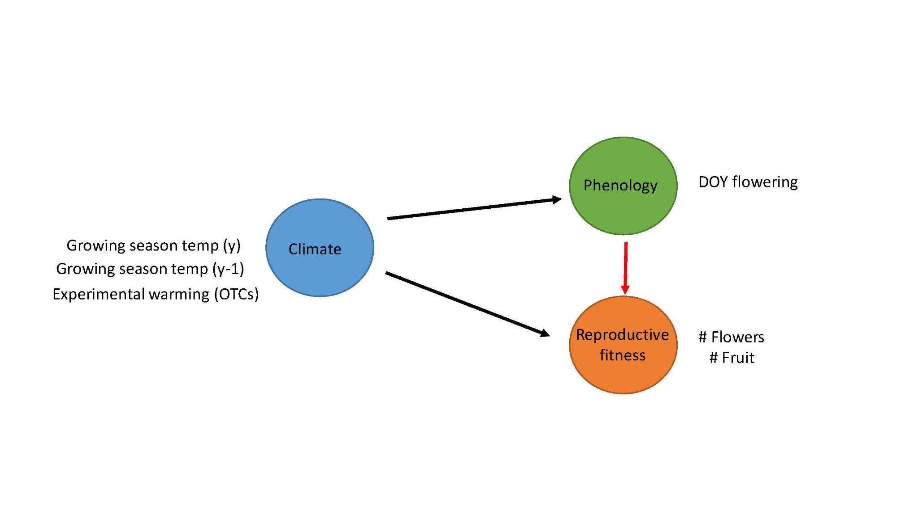

**Fig 2**. Structural equation meta-model with proposed relationships and specific parameters measured for each node of the model. Growing season=June-August and y=current year, y-1=previous year for the Daring Lake dataset. For the Alexandra Fiord dataset, we used the experimental warming effect (OTC vs CTL) as the climate parameter. Arrows indicating direct effects of climate are black and the arrow indicating indirect effects of climate via phenology shifts are red. Black arrows were estimated with linear relationships and the red arrow was estimated with both linear and quadratic relationships.

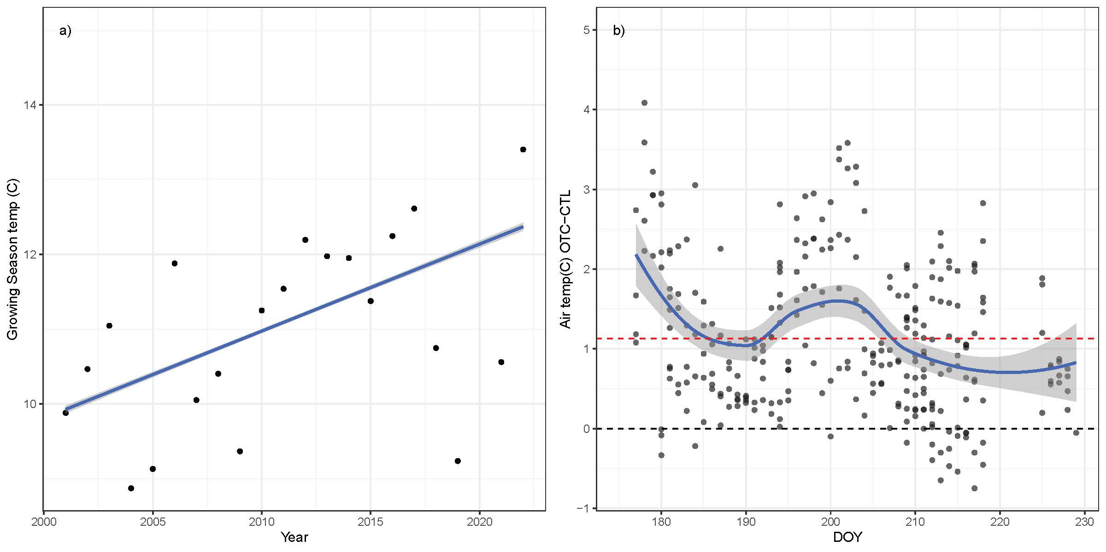

y= 0.116x – 0.022

**Fig 3**. Baseline climate (temperature) data at Daring Lake (a) and Alexandra Fiord (b) over the respective study periods. a) Average growing season (June-Aug) air temperature at the site level (all plots, species) from 2001–2022 and b) Average air temperature differences (i.e. Δ) between warming (OTC) and control plots by calendar date (DOY) across 2 growing seasons (2001, 2002). Dotted black line indicates no difference in temperature between warming and control plots (i.e. 0), and dotted red line indicates the average difference in temperature between warming and control plots across the growing seasons (~1.1°C). Best-fit lines (solid blue plus error) are plotted on raw data with the function ‘geom_smooth’ (method= a) lm, b) loess) in the R package ggplot2 (Wickham 2009). Ambient air temperature for Alexandra Fiord across all years of the time series shown in Fig S1b.

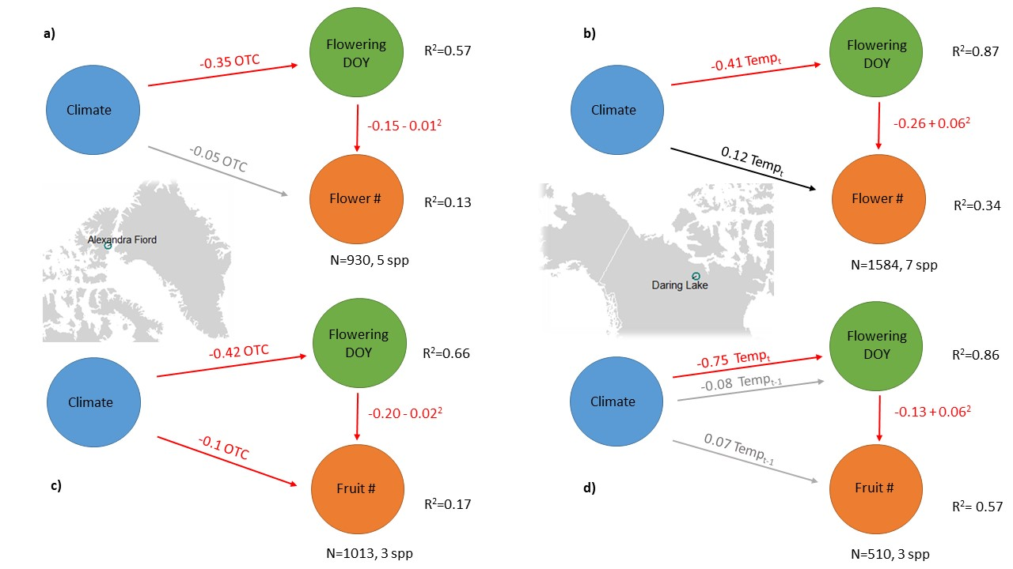

**Fig 4.** Results of Hierarchical Bayesian multivariate models (i.e. Bayesian SEMs) corresponding to Figure 2 for each site and reproductive fitness metric a, b) flower number, c, d) fruit number. Climate parameters included in each model are indicated on arrows (Tempt= average growing season temperature in the current year, Tempt-1 = average growing season temperature in the previous year and OTC = OTC experimental warming effect). Red/black lines indicate a negative/positive relationship, respectively, and grey lines indicate no evidence of a relationship based on Bayesian Credible Intervals. Parameter estimates (zero centered) for model slopes are shown on each line, including both linear and quadratic slopes are shown for the flowering phenology – reproductive fitness models (red arrow, Fig 2). All parameter estimates plus error are reported in Table 2.

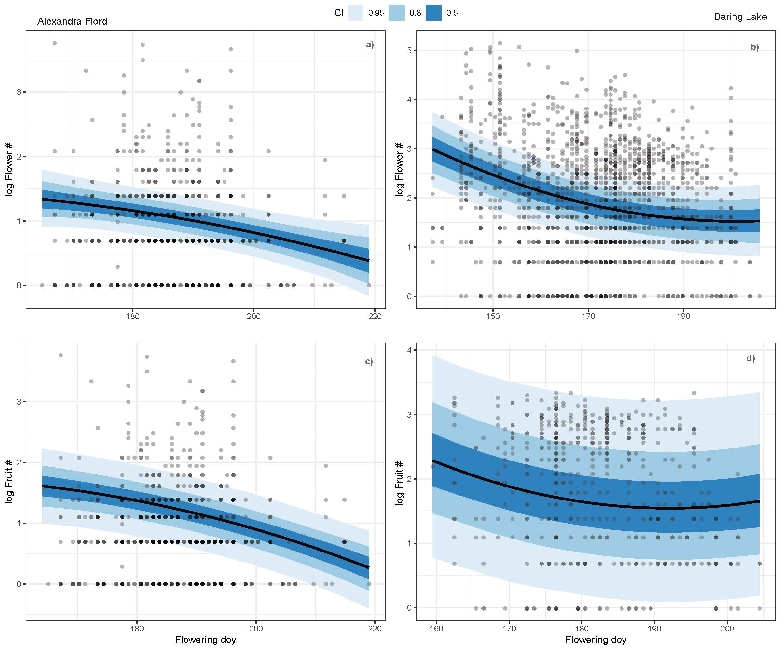

**Fig 5.** Model prediction lines for the relationship between flowering phenology and reproductive fitness (red arrow, Fig 2) within Hierarchical Bayesian multivariate models (i.e. Bayesian SEMs) for each site and fitness metric a, b) flower number, and c, d) fruit number. Black lines indicate model predictions over observed data with 50, 80, and 95% Bayesian credible intervals shown in increasingly light shades of blue. Dots show the raw data in each model (note distinct X & Y axes for each panel).

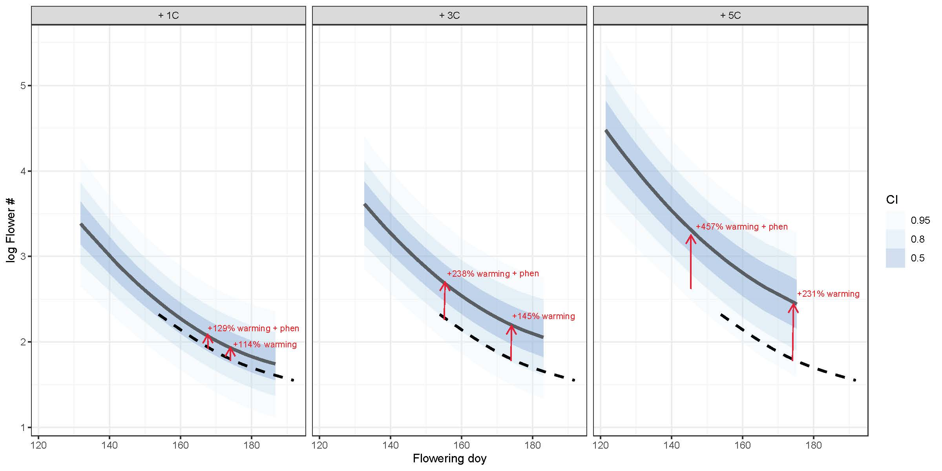

**Fig 6.** Model projections for the relationship between flowering phenology and reproductive fitness (flower number- logged) at Daring Lake with an increase in average growing season (June- August) air temperatures over historic values (2001-2022) by 1, 3 and 5 degrees C. Solid black lines indicate model projections over novel climate data with 50, 80, and 95% Bayesian credible intervals shown in blue. Dotted black lines indicate model predictions from historic values (Fig 5b). Red arrows correspond to the two model projections for reproductive fitness under each climate scenario (Table 4) including 1) as a direct response of temperature only holding flowering time at the historic median DOY and 2) as the combined direct response to temperature and indirect response to shifting phenology to the median predicted flowering DOY of that scenario (Table 4). For each panel, the right arrow shows the percent change in reproductive fitness from historic values if individual plants respond to warming only (are unable to shift flowering phenology) and the left arrow shows the percent change in reproductive fitness from historic values if individual plants respond both directly to warming and indirectly to warming by advancing flowering times.

**Table 1. Climate variable model selection**

Results of AICc model selection for climate variables at Daring Lake. Linear mixed effects models included the following climate parameters 1. Tempt=average daily growing season (June-August) temperature (°C) of the current year, 2. Tempt-1= average daily growing season (June-August) temperature (°C) of the previous year, and 3. First date observed snow free for each species in the current year and random intercepts of species, individual plant id nested within species and calendar year. When the first and second model were significantly different (delta AICc >2), we chose the best model and when multiple models were equivalent (delta AICc <2), we chose the simplest of the best candidate models. Based on these criteria, the climate parameters for each response type: phenology (date of flowering), and reproductive fitness (flower number, fruit number) used in downstream analyses are shown in bold.

|  |  |  |  |
| --- | --- | --- | --- |
| **Model response** | **Climate predictors** | **AICc** | **Delta_AICc** |
| Flowering DOY | Tempt + Snow free DOY | 32435.63 | 0 |
|  | Tempt + Temp (prev) + Snow free DOY | 32436.02 | 0.39 |
|  | Tempt | 32436.05 | 0.42 |
|  | Tempt + Temp (prev) | 32436.54 | 0.91 |
|  | Temp (prev) + Snow free DOY | 32457.72 | 22.09 |
|  | Temp (prev) | 32458.58 | 22.95 |
|  | Snow free DOY | 32460.42 | 24.79 |
| Flower number | Tempt | 4303.49 | 0 |
|  | Tempt + Temp (prev) | 4307.38 | 3.9 |
|  | Temp (prev) | 4312.38 | 8.9 |
|  | Tempt + Snow free DOY | 4313.01 | 9.52 |
|  | Tempt + Temp (prev) + Snow free DOY | 4316.98 | 13.49 |
|  | Snow free DOY | 4318.84 | 15.36 |
|  | Temp (prev) + Snow free DOY | 4320.27 | 16.78 |
| Fruit number | Temp (prev) | 1018.97 | 0 |
|  | Tempt | 1023.18 | 4.2 |
|  | Temp (prev) + Snow free DOY | 1023.79 | 4.81 |
|  | Tempt + Temp (prev) + Snow free DOY | 1023.91 | 4.94 |
|  | Tempt + Temp (prev) | 1023.97 | 5 |
|  | Tempt + Snow free DOY | 1025.13 | 6.16 |
|  | Snow free DOY | 1026.76 | 7.79 |

**Table 2. Structural Equation Modeling**

Results of Hierarchical Bayesian multivariate models (i.e. Bayesian SEMs) corresponding to Figure 4 for each site and reproductive fitness metric. Parameter estimates for model Intercepts and slopes for ‘fixed effects’ of climate and phenology with 95% Bayesian credible intervals (high, low) and Bulk effective sample size (ESS) estimates. Tempt= average growing season temp in the current year, Tempt-1 average growing season temp in the previous year and OTC = OTC warming effect. DOY= Day of year of flowering.

|  |  |  |  |  |  |  |  |  |
| --- | --- | --- | --- | --- | --- | --- | --- | --- |
| **Site** | **Model** | **Response** | **Parameter** | **Estimate** | **Est.Error** | **95 low** | **95 high** | **Bulk_ESS** |
| Daring Lake | Flower number | Flowering DOY | Intercept | 0.065 | 0.399 | -0.72 | 0.877 | 3060 |
|  |  | Flower number | Intercept | -0.143 | 0.267 | -0.686 | 0.395 | 3705 |
|  |  | Flowering DOY | Tempt | -0.413 | 0.064 | -0.537 | -0.286 | 2802 |
|  |  | Flower number | Tempt | 0.12 | 0.055 | 0.01 | 0.229 | 5551 |
|  |  | Flower number | Flowering DOY | -0.264 | 0.054 | -0.371 | -0.157 | 11740 |
|  |  | Flower number | Flowering DOY2 | 0.063 | 0.02 | 0.025 | 0.102 | 17603 |
| Daring Lake | Fruit number | Flowering DOY | Intercept | -0.049 | 0.761 | -1.716 | 1.505 | 4606 |
|  |  | Fruit number | Intercept | -0.31 | 0.778 | -1.9 | 1.368 | 5090 |
|  |  | Flowering DOY | Tempt | -0.748 | 0.183 | -1.115 | -0.381 | 2921 |
|  |  | Flowering DOY | Tempt-1 | -0.083 | 0.182 | -0.443 | 0.28 | 2703 |
|  |  | Fruit number | Tempt-1 | 0.069 | 0.057 | -0.047 | 0.177 | 4647 |
|  |  | Fruit number | Flowering DOY | -0.134 | 0.054 | -0.241 | -0.032 | 6678 |
|  |  | Fruit number | Flowering DOY2 | 0.061 | 0.029 | 0.004 | 0.119 | 10525 |
| Alexandra Fiord | Flower number | Flowering DOY | Intercept | 0.155 | 0.315 | -0.478 | 0.777 | 2638 |
|  |  | Flower number | Intercept | 0.873 | 0.179 | 0.517 | 1.226 | 3637 |
|  |  | Flowering DOY | OTC | -0.35 | 0.04 | -0.43 | -0.272 | 16466 |
|  |  | Flower number | OTC | -0.047 | 0.046 | -0.136 | 0.041 | 15703 |
|  |  | Flower number | Flowering DOY | -0.146 | 0.035 | -0.214 | -0.078 | 10175 |
|  |  | Flower number | Flowering DOY2 | -0.012 | 0.017 | -0.046 | 0.022 | 11751 |
| Alexandra Fiord | Fruit number | Flowering DOY | Intercept | 0.438 | 0.596 | -0.808 | 1.589 | 2992 |
|  |  | Fruit number | Intercept | 1.142 | 0.314 | 0.57 | 1.719 | 3147 |
|  |  | Flowering DOY | OTC | -0.424 | 0.039 | -0.501 | -0.346 | 19108 |
|  |  | Fruit number | OTC | -0.112 | 0.036 | -0.182 | -0.042 | 14940 |
|  |  | Fruit number | Flowering DOY | -0.201 | 0.026 | -0.251 | -0.15 | 12708 |
|  |  | Fruit number | Flowering DOY2 | -0.02 | 0.012 | -0.043 | 0.004 | 16283 |

**Table 3. Group level effects summary**

Group level hyperparameters (i.e. standard deviation) and residual error from hierarchical Bayesian multivariate models (i.e. Bayesian SEMs). Group level terms (i.e. random intercepts) for each site and reproductive fitness metric correspond to Equations 1 and 2 in the main text.

|  |  |  |  |  |  |
| --- | --- | --- | --- | --- | --- |
| **Site** | **Model** | **Response** | **Group** | **SD** | **Error** |
| Daring Lake | Flower number | Flowering DOY | Species | 1.005 | 0.366 |
|  |  | Flowering DOY | Species:Plantid | 0.022 | 0.015 |
|  |  | Flowering DOY | Year | 0.278 | 0.05 |
|  |  | Flower number | Species | 0.648 | 0.259 |
|  |  | Flower number | Species:Plantid | 0.361 | 0.034 |
|  |  | Flower number | Year | 0.206 | 0.044 |
| Daring Lake | Fruit number | Flowering DOY | Species | 1.25 | 0.876 |
|  |  | Flowering DOY | Species:Plantid | 0.062 | 0.031 |
|  |  | Flowering DOY | Year | 0.733 | 0.14 |
|  |  | Fruit number | Species | 1.331 | 0.89 |
|  |  | Fruit number | Species:Plantid | 0.215 | 0.051 |
|  |  | Fruit number | Year | 0.206 | 0.053 |
| Alexandra Fiord | Flower number | Flowering DOY | Species | 0.43 | 0.265 |
|  |  | Flowering DOY | Site:Plot | 0.443 | 0.064 |
|  |  | Flowering DOY | Year | 0.646 | 0.186 |
|  |  | Flower number | Species | 0.244 | 0.173 |
|  |  | Flower number | Site:Plot | 0.177 | 0.041 |
|  |  | Flower number | Year | 0.328 | 0.103 |
| Alexandra Fiord | Fruit number | Flowering DOY | Species | 0.754 | 0.679 |
|  |  | Flowering DOY | Site:Plot | 0.469 | 0.064 |
|  |  | Flowering DOY | Year | 0.97 | 0.262 |
|  |  | Fruit number | Species | 0.314 | 0.429 |
|  |  | Fruit number | Site:Plot | 0.047 | 0.027 |
|  |  | Fruit number | Year | 0.492 | 0.154 |

**Table 4. Future model projections**

Bayesian multivariate model projections over novel climate scenarios corresponding to Fig 6. Models predict flowering phenology (DOY) and reproductive fitness (flower number) at Daring Lake over four climate scenarios including Historic (2001-2022) growing season (Jun- Aug) average air temperatures, and an increase by 1, 3 and 5 degrees C over historic averages. Median flowering DOY reflects the median flowering date predicted in each scenario. For reproductive fitness, we predicted the corresponding mean flower number (logged) for each climate scenario two ways: 1) as a direct response of temperature only (Tempt) holding flowering time at the historic median DOY (173) and 2) the combined direct response to temperature and indirect response to shifting phenology to the median predicted flowering DOY of that scenario (Tempt + phenology).

|  |  |  |  |
| --- | --- | --- | --- |
| Climate scenario | Median flowering DOY | Mean flower number (log) ~ Tempt | Mean flower number (log) ~  Tempt + phenology |
| Historic | 173 | 1.82 | 1.82 |
| Historic +1C | 167 | 1.95 | 2.1 |
| Historic + 3C | 155 | 2.2 | 2.69 |
| Historic + 5C | 145 | 2.67 | 3.34 |

**Funding**

Financial support over the years for research at Alexandra Fiord was provided through grants to G.H.R.H. from the Natural Sciences and Engineering Resource Council (NSERC) of Canada, the Northern Scientific Training Program (Polar Knowledge Canada), ArcticNet, and the Government of Canada International Polar Year program. C. G. Collins was supported by a UBC Biodiversity Research Centre Postdoctoral Fellowship. Sarah C. Elmendorf was supported by the National Science Foundation (NSF OPP 1836839). Cassandra Elphinstone was a Vanier Scholar as well as funded by the Weston Foundation for Northern Research.

**Acknowledgements**

We acknowledge that the research at Alexandra Fiord was conducted on Inuit-owned Land and thank the Qikiqtani Inuit Association and the communities of Resolute Bay and Grise Fiord for their support. The field research was conducted under research licenses from the Aurora Research Institute (Northwest Territories) from 1992 to 1998, and from the Nunavut Research Institute and the Nunavut Department of Environment from 1999 to 2015. We thank all the field assistants, graduate students and postdocs for their help in collecting valuable data over the years of these experiments. We are grateful to the Polar Continental Shelf Program and the Royal Canadian Mounted Police for providing logistical support for all of the years of research at Alexandra Fiord.

**Data Availability**

All data and scripts at <https://github.com/cour10eygrace/ITEX_pheno_demo>